PROJECT REPORT
On
File Encryption with C++
(CSE III Semester Mini project)
2020-2021

Submitted to: Submitted by:
Miss. Manika Manwal Mr. Mohit Sharma
(CC-CSE-E-III-Sem) Roll. No.: 1918483
Guided by: CSE-E-III-Sem
Mr. Session: 2020-2021
(Resource Person)

DEPARTMENT OF COMPUTER SCIENCE AND INFORMATION TECHNOLOGY
GRAPHIC ERA HILL UNVERSITY, DEHRADUN
CERTIFICATE

Certified that Mr. Mohit Sharma (Roll No.- 1918483) has developed mini project on “File Encryption with C++” for the CS III Semester Mini Project Lab (PCS-504) in Graphic Era Hill University, Dehradun. The project carried out by Students is their own work as best of my knowledge.

Date: 1-december-2020

(Miss. Manika Manwal)
Project Co-ordinator
CC-CSE-E-III-Sem
(CSE Department)
GEHU Dehradun

(Dr. Ashook Sahoo)
Project Guide
Resource Person
(CSE Department)
GEHU Dehradun

ACKNOWLEDGMENT

would like to express our gratitude to, the most Beneficent and the most Merciful, for completion of project.
We wish to thank our parents for their continuing support and encouragement. We also wish to thank them for providing us with the opportunity to reach this far in our studies.
We would like to thank particularly our project Co-ordinator Miss. Manika Manwal Dubey and our Project Guide Dr. Ashook Sahoo for his patience, support and encouragement throughout the completion of this project and having faith in us.
We also acknowledge to teachers who help us in developing the project.
At last but not the least We greatly indebted to all other persons who directly or indirectly helped us during this work.

Mr. Mohit Sharma
Roll No.- 1918483
CSE-E-III-Sem
Session: 2020-2021
GEHU, Dehradun We
TABLE OF CONTENTS

CHAPTER NO. TITLE PAGE NO.

LIST OF FIGURES 6
LIST OF ALGORITHMS 7

1. INTRODUCTION 8
1.1 About Project 8
1.2 What is Encryption 9
2. PROJECT 10
2.1 Requirement Analysis 10
2.2 Software Specification 10
2.3 E-R Diagram /DFD 11
2.4 Module 11
2.4.1 Entry of file 11
2.4.2 Selection of Option 12
2.4.3 Creating new File 12
2.4.4. Providing key 12
2.4.5 Decryption of File 12
2.5 Application 13
2.6 Algorithms 14

3. SNAPSHOT OF PROJECT 16
3.1 Source File Snapshot 16
3.2 Encryption process 17
3.3. Decryption process 18

4. CONCLUSION 19
4.1 CONCLUSION 19
4.2 FUTURE WORKS 19

APPENDIX: CODE 20
REFERENCE 27

LIST OF FIGURES

FIGURE Page No.

Figure 2.1 Data flow diagram of Project 16

LIST OF ALGORITHMS

ALGORITHM Page No.
Algorithm 2.1 Encryption function Algorithm 17
Algorithm 2.2 Decryption function Algorithm 19

CHAPTER 1
INTRODUCTION

  - ABOUT PROJECT
This Project is based on File Encryption and decryption process. In this project I’ve created a program that takes a file as command line input. Input is the name of any type of file that we want to encrypt or decrypt.
The main feature of my project are:
1. Protection Feature with Secret key
When a user selects an option to encrypt a file in that case, he has to provide a secret key that will get stored in encrypted file at random position. This key value acts as a password. In case if user wants to decrypt the same file, then he has to provide the same key value or password to continue the file decryption process. In case password does not matches then the program exits with an error message.

2. While Encrypting and Decrypting this program also shows progress how much amount of data has been encrypted.

3.It is capable of encrypting as well as decrypting any type of file. For example, if file is abc.txt/dox/pdf then encrypted file will be abc.txt. ecrypt.

4.Maximum Size limit
The maximum file size that this program support is 1 Gb.
This is a C++ based project and this project report contains in depth demonstration of Data Encryption and Decryption system along with its working architecture which contains brief introduction, features, outputs, source code, Algorithms and at last references.

  - WHAT IS ENCRYPTION AND DECRYPTION
Encryption is the process of taking plain text, like a text message or email, and scrambling It into an unreadable format – called “cipher text”.

When the intended recipient accesses the message, the information is translated back to its original form. This is called decryption.
To unlock the message, both the sender and the c=recipient have to use “secret” key – a collection of algorithm that scramble and unscramble data back to a readable format.

CHAPTER 2
PROJECT

2.1 REQUIREMENT ANALYSIS
Name: Simple Password Encryption in C++
Features: Uses simple algorithm to encrypt the file
Explanation: This Project use the concept of secret key which is to be given by user during encryption process. After getting the key, it is decrypted with the simple algorithm so that no other person than the authorized one can be able to view the content of file.
2.2 SOFTWARE SPECIFICATION
2.2.1 Tool Required and Requirement:
- Linux Environment
- CodeBlocks IDE
- Terminal
- Ram Minimum 512 MB

2.3 DATA FLOW DIAGRAM
MAIN MENU
choice
Encryption Decryption
Insert Secret key ENCRYPTION
Provide Secret key ENCRYPTION
Not matched

DECRYPT DATA FROM
A ENCRYPTED FILE
ENCRYPT DATA FROM
A SOURCE FILE

EXIT
Figure 2.3.1 Flowchart of Project

  - MODULE
2.4.1 Entry of File.
In the program file name with path is given as an command line input. If file is not found at the path entered by the user then the program displays an error message on console and exits with error otherwise executes further

2.4.2 Selection of Option
After inputting the source file path, we have two options as shown in the figure. Choosing 1 option will led to encryption and second option will led to decryption. To select an option, the user will have to enter his choice. The feel of main menu is kept simpler so that anyone who doesn’t prior knowledge about encryption and decryption can also be able to use this easily.
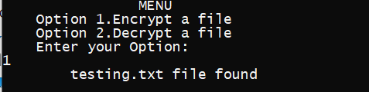

2.4.3 Creating new file
If source file have been found successfully, then the program asks the user to enter the name of the new file in which encrypted data will gets stored. After processing it creates a new file named Abc.txt.ecrypt or Abc.txt.decrypt in the same directory which will contain the encrypted data. This Step is also similar in decryption process as well.
2.4.4 Providing a key/password
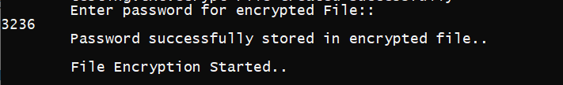
In next step user have to enter a key value, this key value can be anything. Let us take an example, suppose user have entered 326 then this 326 will added to each character of file. The key value and each character gets stored in the new encrypted file.

2.4.5 Decrypting the file
To decrypt the same file, it is necessary to remember the key value, if user have forgotten it then there is no way to access the content of encrypted file.
To decrypt the same file user, have to provide the file path again as a command line input and have to select an option of decrypt. Then the program asks for key, if the key entered by user is correct then a new file will get created with decrypt extension.

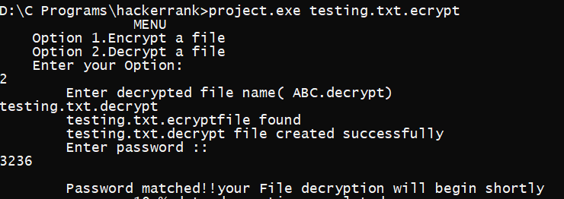

  - APPLICATION
- Encryption is the process of taking plain text, like a text message or email, and scrambling it into an unreadable format — called “cipher text.” This helps protect the confidentiality of digital data either stored on computer systems or transmitted through a network like the internet.
  - ALGORITHMS
2.6.1 Encryption process algorithm
- Start
- Input File name by user
- argv[1]=Abc.txt
- Open argv[1] file in read mode
- If (file not found)
Goto step 16
- Fp1=starting location of the source file
- Create new file name abc.txt.ecrypt in write mode
- If (not created)
  - Goto step 16
- Fp2=starting location of encrypted file
- Input a key by user
- Store this key in file pointed by fp2
fputc(key,fp2)
- Repeat for i=0 to end of file
ch=get integer from File pointed by fp1
if(ch==EOF)
goto to step 16
otherwise
ch=+key
write ch into encrypted file pointed by fp2
fp2=fp2+fp2
14.close source file
15.close encrypted file
16.stop
2.6.2 Decryption process algorithm
1.Start
2. Input file name by user
3.argv[1]=abc.txt.ecrypt
4.open argv[1] in read mode
5.if file not found
Goto to step 16
6.fp1=starting location of source file argv[1]
7.create a new file as abc.txt.decrypt in write mode
8.if file not found
Goto to step 16
9.fp2=starting location of decrypted file created
10. read key from fp1 file as key1
11.input key from user as key2
12.if key1!=key2
Goto to step 16
13.Repeat for i=0 till EOF reached
ch=get integer from File pointed by fp1
if(ch==EOF)
goto to step 16
otherwise
ch=-key
write ch into encrypted file pointed by fp2
fp2=fp2+fp2
14.close fp1
15.close fp2
16.Stop

CHAPTER 3
SNAPSHOT OF PROJECT

3.1 SOURCE FILE CONTENT

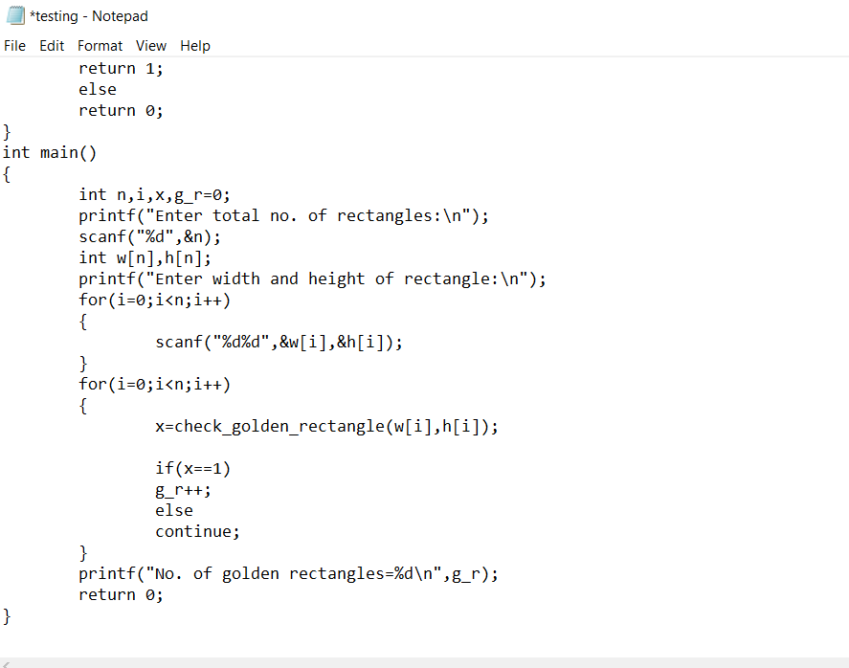

3.2 ENCRYPTION PROCESS
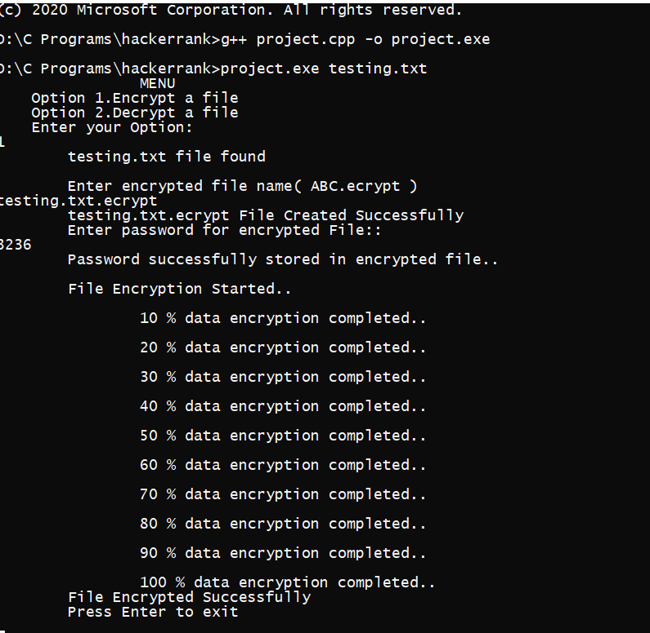
3.2 .1 ENCRYPTED FILE
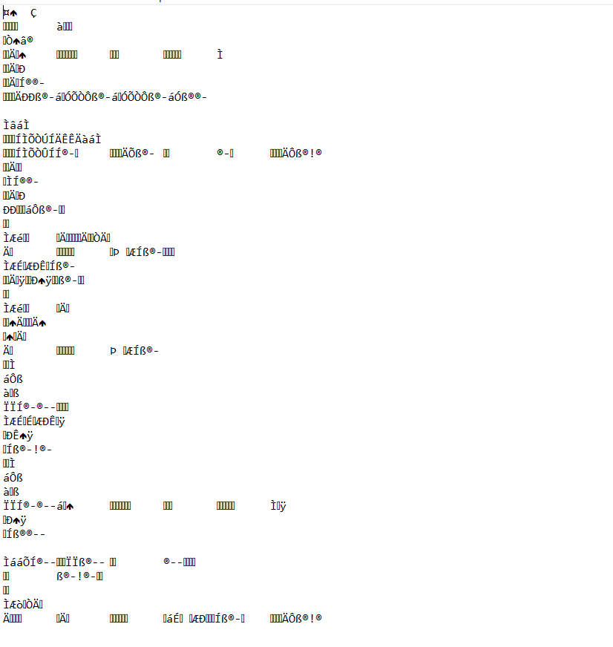
3.3 DECRYPTION PROCESS
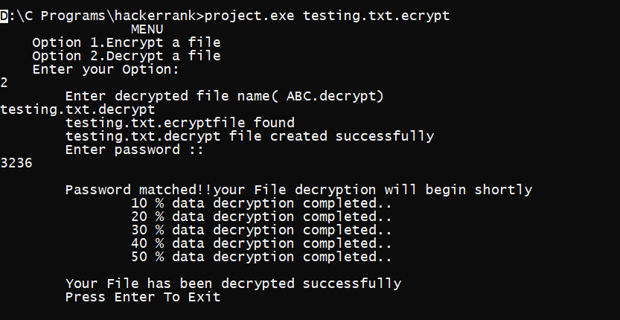

3.3.1 DECRYPTED FILE
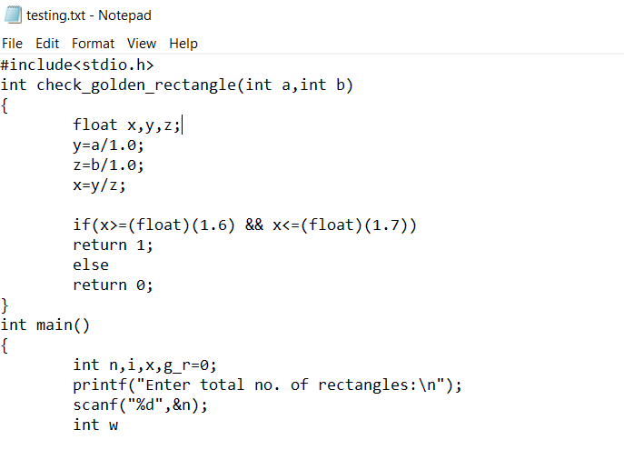
CHAPTER 4
CONCLUSION
4.1 CONCLUSION
It can be concluded that this project works efficiently for offline purpose at any place provided the requirements for running environment remains same. Users need not to worry about how the algorithm actually works inside the instruction set performed by the compiler.

4.2 FUTURE SCOPE
1. In Future, Data Encryption and Decryption system can be updated further which can provide more secured encryption algorithms.
2. This project can be made more attractive and easy to use by implementing GUI(Graphical User Interface) with the help of many coding platforms like Netbeans etc.

APPENDIX
Code

#include<iostream>
#include<stdio.h>
#include<conio.h>
#include<stdlib.h>
#include<ctype.h>
#include<math.h>

using namespace std;

int file_size(FILE**fp1)
{
fseek(*fp1,0L,2); //point file pointer to end of source file int s=ftell(*fp1);
//storing file size returned by ftell function
if(s>(pow(2,30))) //checking file size
{
cout<<'\t'<<"Maximum size of file should not be greater than 1Gb"<<endl; cout<<endl<<'\t'<<"Press Enter to exit"<<endl;
getch();
exit(1); //end of program
}
rewind(*fp1); //point file pointer again at starting
return s;
}
void encrypt_file(FILE **fp1,FILE **fp2,int key,int max_size)
{
char ch;
int i=10,curr_position,percent;
//writing key value into new encrypted file// putw(key,*fp2);
cout<<'\t'<<"Password successfully stored in encrypted file.."<<endl; cout<<endl<<'\t'<<"File Encryption Started.."<<endl;
while(1)
{
ch=getc(*fp1); //reading characters one by one if(ch==EOF)
{
cout<<'\t'<<"File Encrypted Successfully"<<endl;
return; //exit if end of file reached
}//end of if block
else
{
ch+=key; //add key to character and write it to file fputc(ch,*fp2);
curr_position=ftell(*fp1);
percent=(i*max_size)/100;
if(curr_position==percent)
{
cout<<endl<<'\t'<<'\t'<<i<<" % data encryption completed.."<<endl;
i+=10;
}
}//end of else block
}//end of while loop
}//end of encryption function

void decrypt_file(FILE **fp1,FILE **fp2,int max_size)
{
int key=getw(*fp1);
//reading key stored in encrypted file
char ch;
int k,i=10,curr_position,percent;
cout<<'\t'<<"Enter password :: "<<endl;
cin>>k;
if(key==k)
{
cout<<endl<<'\t'<<"Password matched!!your File decryption will begin shortly"<<endl;
while(1)
{
ch=fgetc(*fp1); if(ch==EOF)
{
cout<<endl<<'\t'<<"Your File has been decrypted successfully"<<endl;
return;
}
else
{
ch-=k; //perform same operation on every character fputc(ch,*fp2); // write character to new file curr_position=ftell(*fp1); // store current position of file pointer percent=(i*max_size)/100; //calculate percentage if(curr_position==percent)
{
cout<<'\t'<<'\t'<<i<<" % data decryption completed.."<<endl;
i+=10;
}
}
}
}
else
cout<<'\t'<<"Password not matched!!"<<endl;
}

int main(int argc,char *argv[])
{
FILE *fp1,*fp2;
char file_name[100];
intkey,opt,i=1,max_size; char ch;
do
{
cout<<" MENU"<<endl; cout<<" Option 1.Encrypt a file"<<endl; cout<<" Option 2.Decrypt a file"<<endl; cout<<" Enter your Option:"<<endl;
cin>>opt;

switch(opt)
{
case 1:
fp1=fopen(argv[1],"r"); //open source file if(fp1==NULL)
{
cout<<'\t'<<'\t'<<argv[1]<<"Error!! File can't be open"<<endl;
exit(1); //exit in case of error
} else
{
cout<<'\t'<<argv[1]<<" file found"<<endl;
max_size=file_size(&fp1);
//check for maximum size and store size in variable
}
cout<<endl<<'\t'<<"Enter encrypted file name( ABC.ecrypt )"<<endl; fflush(stdin);
// function to empty memory buffer
cin.get(file_name,50); // read file name entered by user fp2=fopen(file_name,"w"); //create new file and open it in write mode

if(fp2!=NULL)
{
cout<<'\t'<<file_name<<" File Created Successfully"<<endl;
}
cout<<'\t'<<"Enter password for encrypted File:: "<<endl;
fflush(stdin);
cin>>key; //provide a key encrypt_file(&fp1,&fp2,key,max_size);
fclose(fp1); fclose(fp2); //close all file
cout<<'\t'<<"Press Enter to exit"<<endl;
getch();
exit(0); //end of program

case 2:
fp1=fopen(argv[1],"r"); // open encrypted file in read mode cout<<'\t'<<"Enter decrypted file name( ABC.decrypt)"<<endl;
fflush(stdin);
cin.get(file_name,50); //create new decrypted file and open it in read mode fp2=fopen(file_name,"w");
if(fp1==NULL)
{
cout<<'\t'<<'\t'<<argv[1]<<"Error!! File can't be open"<<endl;
exit(1); //exit in case of error
}
else
{
cout<<'\t'<<argv[1]<<"file found"<<endl; max_size=file_size(&fp1);
//calculate max size of file and store the size in max_size
}
if(fp2==NULL)
{
cout<<'\t'<<'\t'<<file_name<<"File cannot be created!!"<<endl;
exit(1);
}
else
cout<<'\t'<<file_name<<" file created successfully"<<endl; decrypt_file(&fp1,&fp2,max_size);
///call decryption function
fclose(fp1);
fclose(fp2);
cout<<'\t'<<"Press Enter To Exit"<<endl;
getch(); exit(0); default:
cout<<'\t'<<"Please Enter a Valid Option"<<endl;
}
}while(toupper(ch)=='Y'); /// end of while loop if not y
getch();
}

REFERENCE

- www.youtube.com/codewithharry
- C++ with Saurabh Sukla/youtube.com
- Let us C by Yashwant Kanetkar.
- Books on C++ and C languages
- Geeks for geeks.com
- WIKIPEDIA
- GOOGLE

